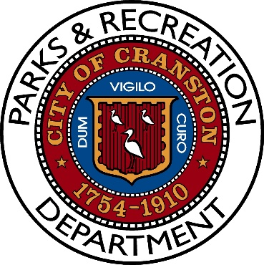

Notice of Meeting
Parks and Recreation Advisory Board Meeting
Tuesday, March 25th, 2025
6:00PM

Pastore Youth Center
155 Gansett Avenue
Cranston, RI 02910

AGENDA

- Roll Call

- Introduction of Director and Members

- Equipment Update

- Capital Budget 2025-2030 update

- Update on Ongoing Projects, what is about to happen.

- Open Dialogue

- Adjourn

